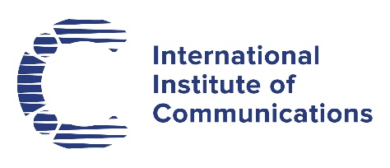

Round-up of the latest news
  - October 2021
Google has announced a $1 billion investment in Africa. It says the money will be focused on connectivity, supporting entrepreneurs and working with non-profits on the continent. The company has also said that it will ‘demonetize’ all content that makes misleading claims about climate change by not allowing any advertising alongside it. The platform will ‘no longer run advertising that contradicts well-established scientific consensus around the existence and causes of climate change.’
SK Broadband, the South Korean internet provider, is suing Netflix to recover costs incurred from increased network traffic. Popular series such as Squid Game have made Netflix the second largest data traffic generator in the country after YouTube. Other providers, such as Amazon, Apple and Facebook, are already paying network usage fees, according to SK Broadband. A South Korean court has previously ruled that recovering costs associated with excessive network usage is reasonable in principle.
Apple has further criticised proposed new EU antitrust rules, arguing that allowing users to install software outside its App Store, so-called ‘sideloading’, would pose risks from cybercriminals and malware. The company had previously said that, if implemented, the rules would create privacy and security risks to iPhones. Meanwhile the bills themselves, the Digital Markets Act and Digital Services Act, are said to be ‘bogged down’ in Brussels, and could be years away from implementation. Disagreements centre on which companies should be included, with some MEPs arguing that it should only be the largest platforms, while others want the legislation to be wider in scope. Currently, only companies with a market value greater than 80 billion euros fall under the proposed rules.
Head of the French Competition Regulator (Autorité de la concurrence) Isabelle de Silva is leaving her post after President Macron declined to renew her mandate. Observers in European legal circles expressed surprise, pointing to her ‘diligent work’ in ‘understanding the complexity’ of the tech sector. She imposed record fines on Google and Apple during her tenure.
The Federal Communications Commission (FCC) is proposing new requirements on phone companies to reduce illegal robocalls emanating from overseas. Domestic ‘gateway providers’ will need to implement Caller ID and blocking technologies, essentially ensuring that foreign-originated calls are treated in the same way as those originating domestically.
Federated Wireless, a US company specialising in shared spectrum capabilities, has launched a spectrum marketplace. The service is designed to allow Citizens Broadband Radio Service (CBRS) users to lease under-utilised spectrum to third parties without reference to the FCC. The company says the exchange is suitable for service providers or organisations needing additional spectrum, to deploy private networks or where spectrum is needed temporarily for high-density events.
Facebook has announced increased protection for some public figures on its platform. Activists and journalists will be treated as ‘involuntary public figures’, meaning that they will be regarded as private citizens, rather than public figures on whom more critical commentary is allowed on the platform. Facebook is under scrutiny following leaks over its content moderation practices.
Sources: The Financial Times, The Guardian, Ars Technica, Reuters, BBC, telecom.com, telecommpaper

